**🎥 Netflix Movies and TV Shows🍿**



## **Introduction**

* The following report provides a comprehensive analysis of Netflix movies and TV shows using data analysis techniques in Python.
* The dataset used for this analysis contains information about various aspects of the content available on Netflix, including directors, cast, countries, release years, genres, and ratings.

# 🔎 DATA ANALYSIS

### **Overview of the Dataset**

* The dataset comprises 8807 rows and 12 columns.
* X duplicates were identified and removed from the dataset.
* The dataset includes the following columns: ['show id', 'type', 'title’ ‘director', 'cast', 'country', 'date added',

'release year', 'rating', 'duration', 'listed in', 'description']

### **Data Preprocessing**

* The "show ID" column was deemed unnecessary and thus removed from the dataset.
* Missing values in the "director", "cast", and "country" columns were replaced with "Unknown".
* Remaining NaN values were removed from the dataset.
* The "date added" column was split to extract the year information and converted to integer data type.
* Data entries where the "date added" year was less than the "release year" were removed.

# 📊DATA VISUALIZATION

### **Top Directors with the Most Movies or TV Shows**

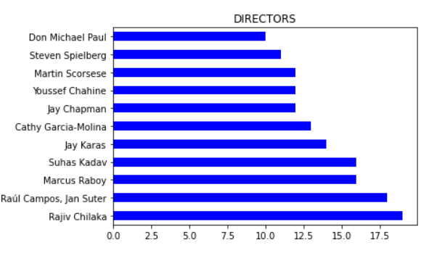

### **Top Countries with the Most Content**

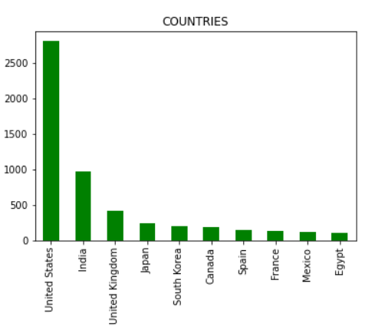

### **Distribution of Content by Country**

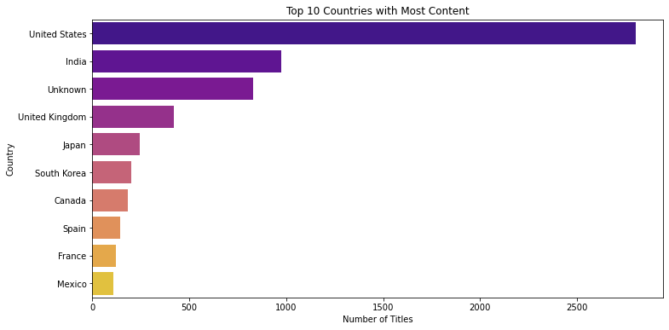

### **Distribution** **of Movie and TV Show Data**

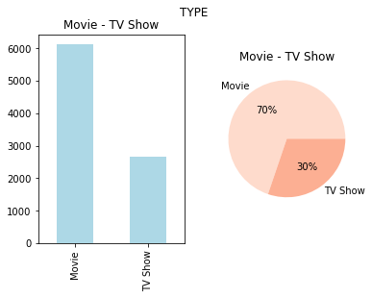

### **Distribution of Content Release Years**

### 

### **Top 10 Most Common Genres**

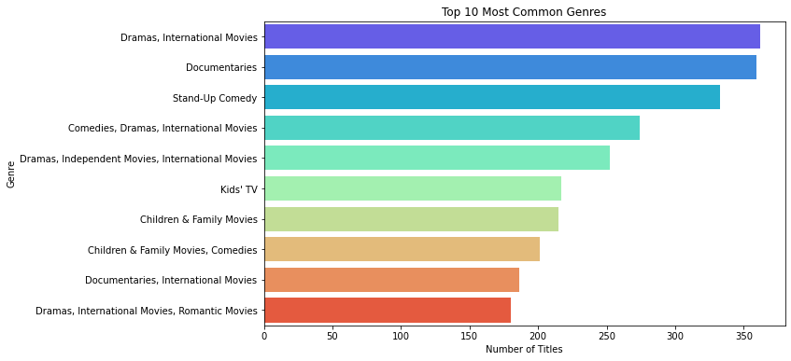

### **Ratings Distribution**

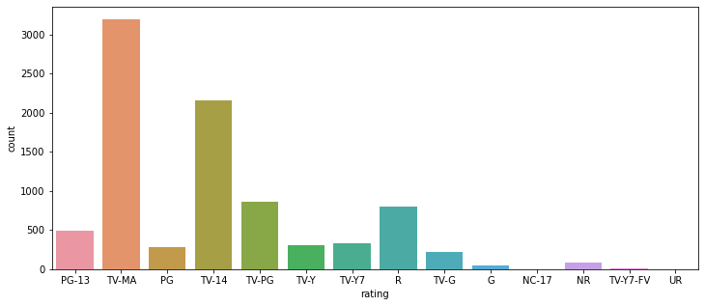

## **Number of Movies and TV shows releases by year**

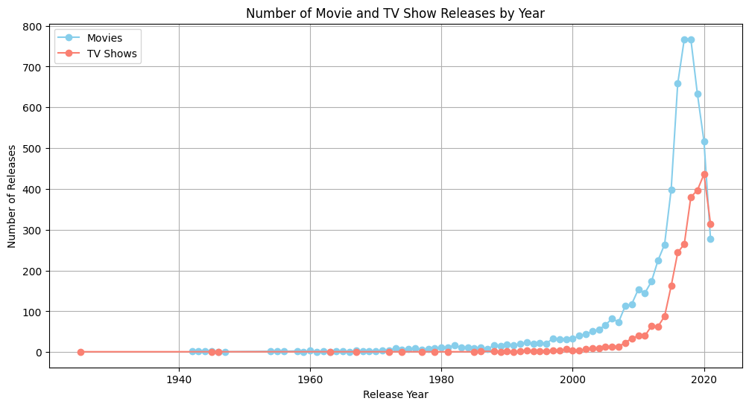

## **Conclusion:**

In conclusion, the analysis of Netflix movies and TV shows provides valuable insights into the content available on the platform. By examining various aspects such as directors, countries, genres, and ratings, we gain a better understanding of Netflix's content landscape.

These findings inform strategic decisions, driving innovation and enhancing user experiences in the ever-evolving landscape of digital entertainment.